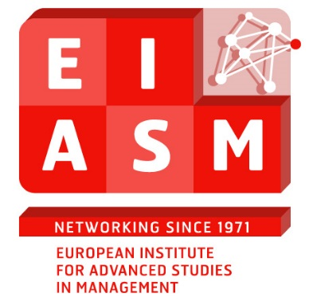  
  
**3rd WORKSHOP ON DIVERSITY ISSUES:**

**AGING AND NEW LIFE PRACTICES**

**Chairpersons:**

****Iiris AALTIO****  
University of Jyväskylä, School of Business and Economics, FINLAND   
  
****Elisabeth SUNDIN****  
Department of Management and Engineering, Helix VINN Excellence Centre, Linköping, SWEDEN  
  
*Brussels, October 15-16, 2015*

PROGRAMME

Day 1

09.00 – 09.30 Registration and coffee (EIASM, second floor)

10.30 -11.00 Introduction. Presentation of the participants  
and of the agenda.   
Iiris Aaltio and Elisabeth Sundin

11.00 -11.30 Carin Holmquist   
“Human and social capital of entrepreneurship from an age perspective”

***Then follows a number of papers taking their starting point in organizations***

11.30 - 12.00 Eleonor Davies and Beatrice van der Heijden.   
“The relationship between organizational support, job satisfaction, retirement affect and retirement intensions for older workers in the UK”

12.00 - 12.30 Sirpa Koponen  
“Factors Influencing Ageing Nurses´ Intentions to Continue Working: A Q-method Study”

12.30 – 14:00 Lunch at the NH Hotel

14:00 - 14.30 Zaman Mohammed Seeman and Eleonor Davies  
“Effects of Human Resource (HR) Practices on Job Satisfaction and Turnover Intentions Among General Practitioners in NHS England”.

***The following papers focus on individual strategies***

14.30 – 15.00 Kerstin Nilsson  
“Organisational Measures and Strategies for a Sustainable Working Life to an Older Age”.

15.00 – 15.30 Coffee break (EIASM, second floor)

15.30 – 16. Kerstin Wentz.   
“Career Crafting: Working in the Age Between 69-75 Years”

16.00 - 16.30 Martin Klinthäll  
“Necessity Entrepreneurship Late in Working Life”

**Day 2**

***First the only paper with young people in focus – illustrating that age concerns everyone***

9.00 - 9.30 Hanna Salminen and Reija Oksanen   
“Generation Y University Students´ Career Expectations”

***The three last papers concern image and strategies***

9.30 - 10.00 Elisabeth Sundin  
“The Older Entrepreneurs a Diversified Group”

10.00 - 10.30 Coffee Break (EIASM, second floor)

10.30 - 11.00 Iiris Aaltio, Qian Wang and Hanna Salminen   
“Age as a Topic in Business Magazines in Finland. How to Prepare for Aging”

11.00 -11.30 Kari Österud   
“Ageing and Work – The Role of the Centre for Senior Policy in Norway”.   
Kari Österud will also reflect on the papers presented from a policy-perspective.

11.10 – 12.00 End of the workshop and conclusions.   
  
12.10 Lunch at the NH Hotel